פרויקט ספר טלפונים

- התקנת SQLite על המחשב המקומי
- הורדת הקובץ sqlite-uwp-3120200.vsix (או גרסה חדשה יותר אם יש) מהאתר https://www.sqlite.org/download.html.
- התקנה.

- פתיחת פרויקט UWP חדש
- הוספת ייחוס ל- SQLite for Universal Windows Platform ול- C++ Runtime
- (Universal Windows -> Extensions Reference Manager-> Add Reference->)

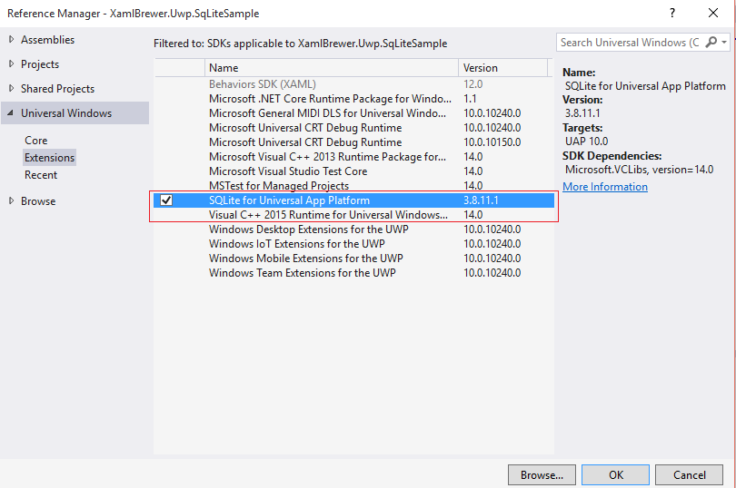

- בשלב זה האפליקציה יכולה כבר לגשת ל-SQLite אבל זה די מורכב לעבוד ישירות מול המנוע של מסד הנתונים, לכו כדאי להתקין את ה-.NET Wrapper של SQLite על מנת לפשט את העבודה.
נצרף את ה-Wrapper – SQLite.Net-PCL באמצעות לפרויקט Nuget:

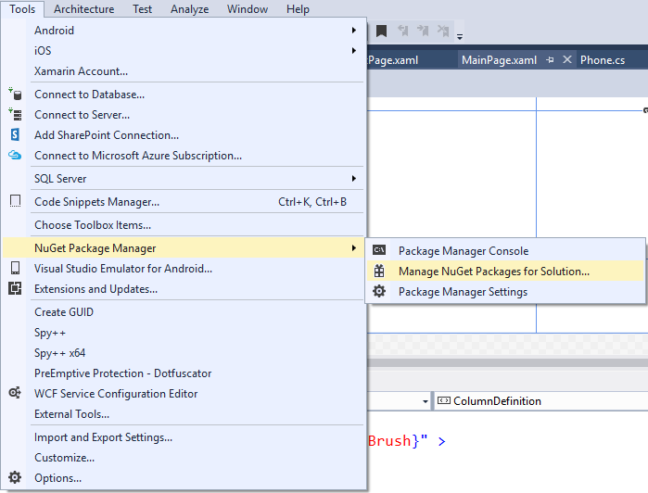

ונוסיף לפרויקט Reference ל-Wrapper:
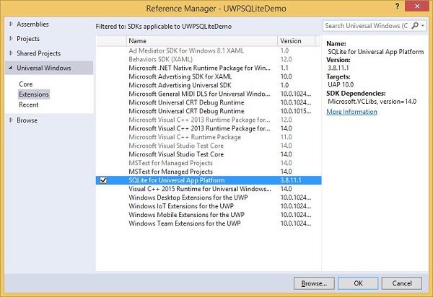

- MainPage – מבנה ה-XAML:
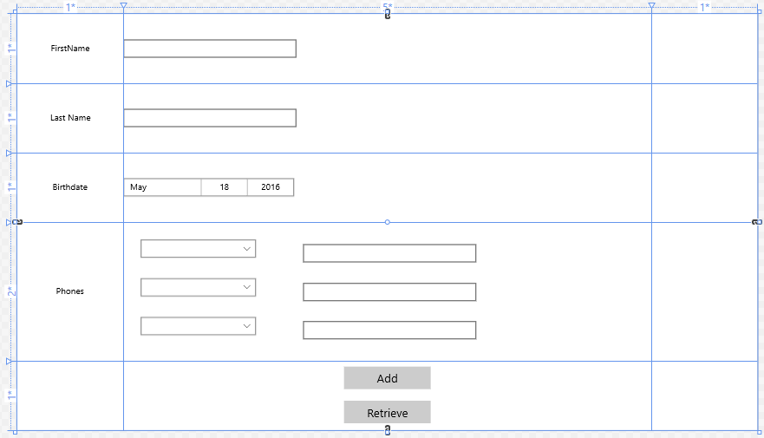

<Grid Background = "{ThemeResource ApplicationPageBackgroundThemeBrush}" >
<Grid.ColumnDefinitions>
<ColumnDefinition Width="*"></ColumnDefinition>
<ColumnDefinition Width="5*"></ColumnDefinition>
<ColumnDefinition Width="*"></ColumnDefinition>
</Grid.ColumnDefinitions>
<Grid.RowDefinitions>
<RowDefinition Height="*"></RowDefinition>
<RowDefinition Height="*"></RowDefinition>
<RowDefinition Height="*"></RowDefinition>
<RowDefinition Height="2*"></RowDefinition>
<RowDefinition Height="*"></RowDefinition>
</Grid.RowDefinitions>
<StackPanel Grid.Column="1" Grid.Row="0">
<TextBlock Name="txtPersonDB" FontSize="20" Margin="3"></TextBlock>
<TextBlock Name="txtPhoneDB" FontSize="20" Margin="3"></TextBlock>
</StackPanel>

<TextBlock Grid.Column="0" Grid.Row="0" Text="FirstName" FontFamily="20" HorizontalAlignment="Center" VerticalAlignment="Center"/>
<TextBox Name="txtFirstName" Grid.Column="1" Grid.Row="0" FontFamily="20" HorizontalAlignment="Left" VerticalAlignment="Center" Width="300"/>

<TextBlock Grid.Column="0" Grid.Row="1" Text="Last Name" FontFamily="20" HorizontalAlignment="Center" VerticalAlignment="Center"/>
<TextBox Name="txtLastName" Grid.Column="1" Grid.Row="1" FontFamily="20" HorizontalAlignment="Left" VerticalAlignment="Center" Width="300"/>

<TextBlock Grid.Column="0" Grid.Row="2" Text="Birthdate" FontFamily="20" HorizontalAlignment="Center" VerticalAlignment="Center"/>
<DatePicker Name="birthDatePicker" Grid.Column="1" Grid.Row="2" />

<TextBlock Grid.Column="0" Grid.Row="3" Text="Phones" FontFamily="20" HorizontalAlignment="Center" VerticalAlignment="Center"/>
<Grid Grid.Column="1" Grid.Row="3" Margin="20">
<Grid.ColumnDefinitions>
<ColumnDefinition Width="*"></ColumnDefinition>
<ColumnDefinition Width="2*"></ColumnDefinition>
</Grid.ColumnDefinitions>
<Grid.RowDefinitions>
<RowDefinition Height="*"></RowDefinition>
<RowDefinition Height="*"></RowDefinition>
<RowDefinition Height="*"></RowDefinition>
</Grid.RowDefinitions>
<ComboBox Name="cboPhoneType1" Grid.Column="0" Grid.Row="0" Width="200" Margin="10"></ComboBox>
<ComboBox Name="cboPhoneType2" Grid.Column="0" Grid.Row="1" Width="200" Margin="10"></ComboBox>
<ComboBox Name="cboPhoneType3" Grid.Column="0" Grid.Row="2" Width="200" Margin="10"></ComboBox>
<TextBox Name="txtPhone1" Grid.Column="1" Grid.Row="0" FontFamily="20" HorizontalAlignment="Left" VerticalAlignment="Center" Width="300"/>
<TextBox Name="txtPhone2" Grid.Column="1" Grid.Row="1" FontFamily="20" HorizontalAlignment="Left" VerticalAlignment="Center" Width="300"/>
<TextBox Name="txtPhone3" Grid.Column="1" Grid.Row="2" FontFamily="20" HorizontalAlignment="Left" VerticalAlignment="Center" Width="300"/>
</Grid>

<StackPanel Grid.Column="1" Grid.Row="4" >
<Button Name="Add" Content="Add" HorizontalAlignment="Center" VerticalAlignment = "Center" Click="Add_Click" Margin="10" Width="150" FontSize="20"/>
<Button Name="Retrieve" Content="Retrieve" HorizontalAlignment="Center" VerticalAlignment = "Center" Click="Retrieve_Click" Width="150" Margin="10" FontSize="20"/>
</StackPanel>
</Grid>

- מבנה נתונים

public class Person
{
[PrimaryKey, AutoIncrement]
public int Id { get; set; }

[MaxLength(20)]
public string FirstName { get; set; }

[MaxLength(20)]
public string LastName { get; set; }

public DateTime DayOfBirth { get; set; }

[SQLite.Net.Attributes.Ignore]
public List<Phone> PhoneList { get; set; }
}

public class Phone
{
[PrimaryKey, AutoIncrement]
public int Id { get; set; }

[MaxLength(8)]
public string PhoneNumber { get; set; }

public PhoneType PhoneType { get; set; }

public int PersonID { get; set; }
[SQLite.Net.Attributes.Ignore]
public Person Person { get; set; }
}
public enum PhoneType { Mobile, Work, Fax, Home}

- בניית טבלאות

תחילה נבדוק שהטבלאות קיימות, במידה ולא נבנה אותם:
public sealed partial class MainPage : Page
{
string path = Path.Combine(Windows.Storage.ApplicationData.Current.LocalFolder.Path,
"db.sqlite");
. . .
public MainPage()
{
this.InitializeComponent();
using (var connection = new SQLiteConnection(new
SQLite.Net.Platform.WinRT.SQLitePlatformWinRT(), path))
{
if (!TableExists<Person>(connection))
{
var c = connection.CreateTable<Person>();
TableMapping info = connection.GetMapping(typeof(Person));
txtPersonDB.Text = info.TableName + " just Created";
}
if (!TableExists<Phone>(connection))
{
var c = connection.CreateTable<Phone>();
TableMapping info = connection.GetMapping(typeof(Phone));
txtPhoneDB.Text = info.TableName + " just Created";
}

}

private bool TableExists<T>(SQLiteConnection connection)
{
var cmd = connection.CreateCommand($"SELECT name FROM sqlite_master
WHERE type='table' AND name='{typeof(T).Name}'");
return cmd.ExecuteScalar<string>() != null;
}

- ComboBox

באמצעות ה-ComboBox ניתן לבחור סוגים של מספרי טלפון (בית, נייד, פקס, עבודה), סוגי הטלפונים מיוצגים באמצעות enum:
public enum PhoneType { Mobile, Work, Fax, Home}

public sealed partial class MainPage : Page
{
. . .
List<PhoneType> PhoneTypeList = new List<PhoneType> { PhoneType.Fax,
PhoneType.Home, PhoneType.Mobile, PhoneType.Work };
public MainPage()
{
. . .
cboPhoneType1.ItemsSource = PhoneTypeList;
cboPhoneType2.ItemsSource = PhoneTypeList;
cboPhoneType3.ItemsSource = PhoneTypeList;
}
}

- הוספת רשומה

private void Add_Click(object sender, RoutedEventArgs e)
{
Person person = new Person();
person.LastName = txtLastName.Text;
person.FirstName = txtFirstName.Text;
person.DayOfBirth = birthDatePicker.Date.DateTime;
using (var connection = new SQLiteConnection(new
SQLite.Net.Platform.WinRT.SQLitePlatformWinRT(), path))
{
var s = connection.Insert(person);
Phone phone;
if (txtPhone1.Text != string.Empty)
{
phone = new Phone();
phone.PersonID = person.Id;
phone.PhoneNumber = txtPhone1.Text;
phone.PhoneType = (PhoneType)cboPhoneType1.SelectedValue;
var p =connection.Insert(phone);
}
if (txtPhone2.Text != string.Empty)
{
phone = new Phone();
phone.PersonID = person.Id;
phone.PhoneNumber = txtPhone2.Text;
phone.PhoneType = (PhoneType)cboPhoneType2.SelectedValue;
var p = connection.Insert(phone);
}
if (txtPhone3.Text != string.Empty)
{
phone = new Phone();
phone.PersonID = person.Id;
phone.PhoneNumber = txtPhone3.Text;
phone.PhoneType = (PhoneType)cboPhoneType3.SelectedValue;
var p = connection.Insert(phone);
}
}
- פורמט תאריך

- מימוש IValueCobverter
public class StringFormatConverter : IValueConverter
{
public object Convert(object value, Type targetType, object
parameter, string language)
{
var format = parameter as string;
if (!String.IsNullOrEmpty(format))
return String.Format(format, value);
return value;
}
public object ConvertBack(object value, Type targetType, object
parameter, string language)
{
throw new NotImplementedException();
}
}

- הצהרה על מחלקת הפורמט ב-XAML
<Page.Resources>
<local:StringFormatConverter x:Key="StringFormatConverter" />
</Page.Resources>

- הגדרת הפורמט בפקד הרלבנטי
<TextBlock Text="{Binding DayOfBirth,
Converter={StaticResource StringFormatConverter},
ConverterParameter='{}{0:dd/MM/yyy}'}"
Margin="20,0,20,8"
FontSize="16"
Foreground="DarkGray"
Opacity="0.8" />

- מעבר לדף הבא - PersonListPage

private void Retrieve_Click(object sender, RoutedEventArgs e)
{
Frame.Navigate(typeof(PersonListPage));
}

- PersonListPage.xaml
<Page.Resources>
<local:StringFormatConverter x:Key="StringFormatConverter" />
</Page.Resources>
<Grid>
<Grid.RowDefinitions>
<RowDefinition Height="10*"></RowDefinition>
<RowDefinition Height="*"></RowDefinition>
</Grid.RowDefinitions>
<ListView x:Name="listPersons" Grid.Row="0"
SelectionChanged="listPersons_SelectionChanged">
<ListView.ItemTemplate>
<DataTemplate>
<StackPanel>
<StackPanel Orientation="Horizontal">
<TextBlock Text="{Binding LastName}"
Margin="20,0,20,8"
FontSize="24"
FontStyle="Italic"
FontWeight="SemiBold"
Foreground="DarkBlue" />
<TextBlock Text="{Binding FirstName}"
Margin="20,0,20,8"
FontSize="24"
FontStyle="Italic"
FontWeight="SemiBold"
Foreground="DarkBlue" />
</StackPanel>
<TextBlock Text="{Binding DayOfBirth,
Converter={StaticResource StringFormatConverter},
ConverterParameter='{}{0:dd/MM/yyy}'}"
Margin="20,0,20,8"
FontSize="16"
Foreground="DarkGray"
Opacity="0.8" />
</StackPanel>
</DataTemplate>
</ListView.ItemTemplate>
</ListView>

<Button Name="btnReturn" Content="Go Back" Grid.Row="1"
FontSize="20" Click="btnReturn_Click"
HorizontalAlignment="Center"></Button>
</Grid>

- הצגת רשימת אנשים

public sealed partial class PersonListPage : Page
{
string path =
Path.Combine(Windows.Storage.ApplicationData.Current.LocalFolder.Path,
"db.sqlite");
public List<Person> list;
public PersonListPage()
{
this.InitializeComponent();
using (var connection = new SQLiteConnection(new
SQLite.Net.Platform.WinRT.SQLitePlatformWinRT(), path))
{
list = connection.Table<Person>().ToList();
listPersons.ItemsSource = list;
}
}

- בחירה באיש קשר בשביל להציג את פרטיו

private void listPersons_SelectionChanged(object sender,
SelectionChangedEventArgs e)
{
Person selected_person = e.AddedItems.First() as Person;
using (var connection = new SQLiteConnection(new
SQLite.Net.Platform.WinRT.SQLitePlatformWinRT(), path))
{
List<Phone> phone_list =
connection.Table<Phone>().Where(item=>item.PersonID ==
selected_person.Id).ToList();
selected_person.PhoneList = phone_list;
Frame.Navigate(typeof(PersonPage), selected_person);
}
}

- מעבר לדף הבא הכולל קבלת פרמטר

Frame.Navigate(typeof(PersonPage), selected_person);

- חזרה לדף קודם

private void btnReturn_Click(object sender, RoutedEventArgs e)
{
Frame.GoBack();
}

- PersonPage.xaml

<Grid>
<Grid.RowDefinitions>
<RowDefinition Height="*"></RowDefinition>
<RowDefinition Height="*"></RowDefinition>
<RowDefinition Height="5*"></RowDefinition>
<RowDefinition Height="*"></RowDefinition>
<RowDefinition Height="*"></RowDefinition>
</Grid.RowDefinitions>
<TextBlock Name="txtName" Grid.Row="1" FontSize="25"
Foreground="DarkBlue" Margin="5"></TextBlock>
<ListView Name="lstPhones" Grid.Row="2">
<ListView.ItemTemplate>
<DataTemplate>
<StackPanel Orientation="Horizontal">
<TextBlock Text="{Binding PhoneType}"
Margin="20,0,20,8"
FontSize="24"
FontStyle="Italic"
FontWeight="SemiBold"
Foreground="DarkBlue" />
<TextBlock Text="-" FontSize="24"
FontStyle="Italic"
FontWeight="SemiBold"
Foreground="DarkBlue" />
<TextBlock Text="{Binding PhoneNumber}"
Margin="20,0,20,8"
FontSize="24"
FontStyle="Italic"
FontWeight="SemiBold"
Foreground="DarkBlue" />
</StackPanel>
</DataTemplate>
</ListView.ItemTemplate>
</ListView>
<Button Name="btnReturn" Content="Go Back" Grid.Row="3"
FontSize="20" Click="btnReturn_Click"
HorizontalAlignment="Center"></Button>
</Grid>

- הצגת פרטי Person

public sealed partial class PersonPage : Page
{
public PersonPage()
{
this.InitializeComponent();
}
protected override void OnNavigatedTo(NavigationEventArgs e)
{
base.OnNavigatedTo(e);
var p = (Person)e.Parameter;
txtName.Text = p.FirstName + " " + p.LastName;
if (p.PhoneList != null && p.PhoneList.Count() > 0)
{
lstPhones.ItemsSource = p.PhoneList;
}
}

- חזרה לדף קודם

private void btnReturn_Click(object sender, RoutedEventArgs e)
{
Frame.GoBack();
}

